Interface Requirement Document

Project Name: Titan

Project ID: 11578

Application Code: ILOS1

Interface Name: RouteInfo

Version: <0.1>
Revision History

Date | Version | Description | Author
07/18/2016 | 0.1 | Initial draft | Keerthi Mothukuri

Reference Documents
Document Name | Version | Shared Location
Project Requirements Document
Solution Architecture Document (SAD) |  | https://project.safeway.com/PWA/17309%20Titan/Working%20Documents/1.%20Analysis%20and%20Design/Arch%20Docs/17309%20-%20Titan%20Phase%201%20%20-%20SAD.docx
Supplemental Specification

Table of Contents

1 Interface Overview 4
1.1 Interface Purpose 4
2 System Context 4
2.1.1 RouteInfo 4
2.2 System Process Flow 5
3 Data Requirements and Interface Definitions 5
3.1 Data Input/Output Formats 5
3.1.1 TMS Input 5
3.1.2 EOM XML: OUTPUT 6
3.2 Transformation and Processing Rules 7
4 Non-Functional Requirements 7
4.1 Transactional Requirements 7
4.2 Capacity Requirements 7
4.3 Service Level Requirements 9
4.4 Error handling requirements 9
4.5 Monitoring requirements 9
5 Assumptions 9
Appendix A – Definitions & Acronyms 9

Interface Overview

Interface Purpose

This Interface updates the Order delivery confirmation (with the “route and stop” information) pertaining to each order in Order management system from TMS application. Interface uses the delivery manifest XML file created by the TMS application to get the delivery confirmation and updates it in order management system for each store and each delivery shift.

System Context

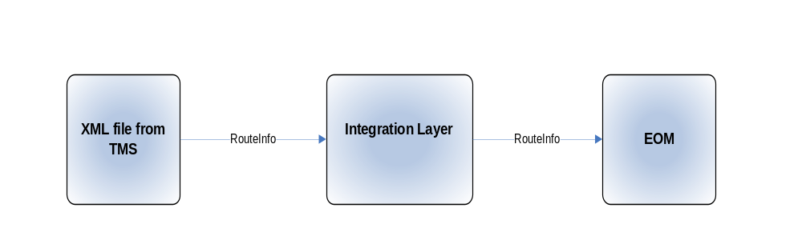

Figure 1 RouteInfo Context Diagram

RouteInfo

Activity | Load RouteInfo to EOM
Description | Extract new and updated orders from shop site sql servers and send them to EOM
Communication Protocol | Inbound: XML message from TMS MQ  Outbound: XML message from EOM MQ
Format | Inbound : XML  Outbound: XML
System Interaction Style | Batch
Timing: | Runs twice a day at 4:30AM and 9:50AM.
Process Trigger: | ESP
Data Entities within LUW: | delivery manifest
Transaction Qualities: | Batch commit. In case of failure, start from point of failure

System Process Flow

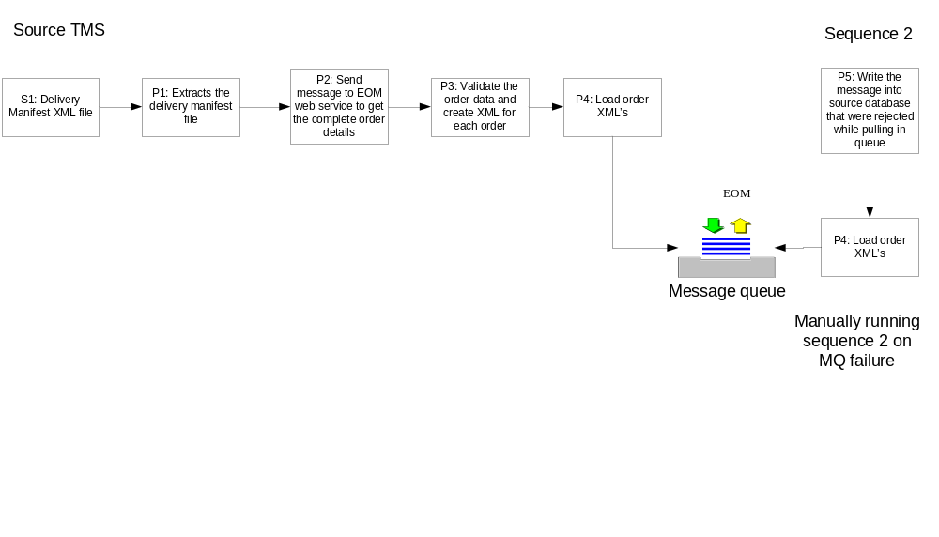

Data Requirements and Interface Definitions

Data Input/Output Formats

TMS Input

Source: Input XML

Column | Data Type
Sender ID | As per XSD
ScheduleID | As per XSD
PlannedArrivedDate | As per XSD
StopNumber | As per XSD
StopID | As per XSD
PlannedBegunDate | As per XSD
PlannedCompletedDate | As per XSD
ResourceKey | As per XSD
PlannedCompletedDate | As per XSD
orderKey | As per XSD
RouteID | As per XSD
StopOrderLine | As per XSD
VanDepartTime | As per XSD
VanArrivalTime | As per XSD

EOM XML: OUTPUT

Order XML fields | Data Type
Header.Source | As per the XSD
Header.Actiontype | As per the XSD
Header.MessageType | As per the XSD
Header.Company ID | As per the XSD
Header.Version | As per the XSD
Channel type | As per the XSD
External System Order ID | As per the XSD
Ref_Field_6 | As per the XSD
Ref_Field_7 | As per the XSD
Ref_Field_13 | As per the XSD
Ref_Field_14 | As per the XSD
Ref_Field_15 | As per the XSD
Ref_Field_10 | As per the XSD
Ref_Field_17 | As per the XSD
Ref_Field_18 | As per the XSD

Target:
Queue: DEV: OSOMDV.CO001.SIL.DOM.ORDER
QA: OSOMQA.CO001.SIL.DOM.ORDER
PROD: OSOMPR.CO001.SIL.DOM.ORDER
Queue Manager: DEV: CODV05
QA: COQAHA06
PROD: COPHA11

Transformation and Processing Rules
Process Step | Rule Statement | Comment
Source S1 | The Source of the interface is the Delivery Manifest xml files from TMS for each store.
Process P1 | This process extracts the Delivery Manifest xml files for each store.
Process P2 | This process will call a webservice which returns the complete order information from EOM
Process P3 | This process validates the orders data and creates xmls for each order.
Process P4 | This process loads the order xmls in the target EOM Queue.
Process P5 | This process copies the failed messages to the source for process P3
Target T1 | The target of this interface is the DOM Application where the Order messages are loaded into the Queue for further processing

Non-Functional Requirements

Transactional Requirements

Capacity Requirements
Data Volume
 | Average | Peak
Expected Data Volume: | 240 files  Average file size is 500 KB | 240 files / day.  Peak file size is 1MB  For each shift the files are generated together and the interface receives a peak load of 90 files at the same time and peak load at this time may go up to 90MB

Record/Message Size
 | Average | Peak
Main Source | 20 bytes | 20 bytes

Concurrency
 | Average | Peak
Expected (‘go live’) concurrency: | N/A | N/A
Forecasted concurrency Rate | N/A | N/A

Service Level Requirements
Availability – Hours of Operation | Runs twice a day at 4:30AM and 9:50AM.
Reliability | N/A
Disaster Recovery Category | DR1
Response Time | N/A
Throughput | N/A
System Failures - Restart, Recovery and Retry | The job is triggered by ESP. In case of failure the job is started from the point of failure.
Assured Transaction delivery | N/A
Security Requirements | N/A
Sequencing Requirements | N/A
Auditing and logging Requirements | Any system error (database connectivity, file system issue) should be recorded in an error log.  No need to create audit for purged records.
Archiving Requirements | The system should archive the individual and combined reject files.  The system should cleanup old (older than 15 days) archive files.

Error handling requirements

Scenario | Expected Behavior
Queue is down | Capture the error in a log file.

Monitoring requirements
Scenario | Expected Behavior
Any system error

Assumptions

N/A

Appendix A – Definitions & Acronyms

# | Acronym | Definition
 | EOM | Enterprise order management
 | DOM | Distributed order management
 | ILOS | Integration Layer online shopping
 | TMS | Transportation Management System

